IT 7742 Advanced Programming
Assessment 1

Karanpreet Singh
20231059

Technical Explanation of UML Diagram and Repo Link

github repo Link: https://github.com/karan9056/Assessment-1_Advanced-Programing_Karanpreet/tree

UML (png) github repo: link:https://github.com/karan9056/Assessment-1_Advanced-Programing_Karanpreet/blob/Sprint1_UML/UML%20Diagram.png

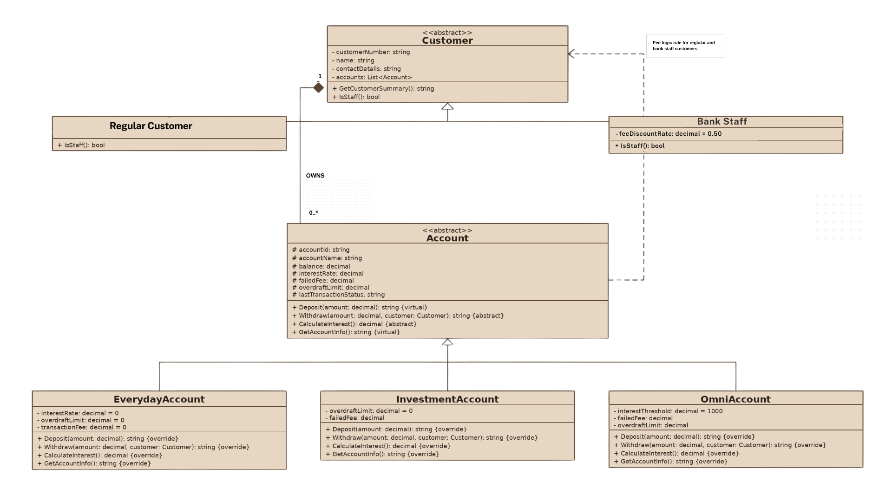

Technical Explanation of UML Diagram

This diagram uses a clearer object-oriented structure for the banking system. The design has two abstract classes, Customer and Account/ Then there are child classes. Account subtypes and customer types. Each child class also contains logic to follow its own logic rule.
Customer class contains the common profile data. This includes customer number, name, and contact details. From this parent class, the system creates RegularCustomer and BankStaff. This is shown with UML generalisation. The hollow triangle arrow points to the parent class, showing inheritance. Both child types are customers, but BankStaff type carries an extra fee discount rule.
Account class stores the shared account data and shared operations. It includes account ID, account name, balance, interest rate, failed fee, overdraft limit, and last transaction status. It also defines the main actions like deposit, withdrawal, interest calculation, and account information display. Then three subclasses that inherit logic from it are EverydayAccount, InvestmentAccount, and OmniAccount.
But these sub account types follow different logic. The everyday account has no interest, no overdraft, and no fee. The investment account earns interest but there is no overdraft and filed withdrawal fee is also applicable. The omni account allows overdraft and only gives interest when the balance is above $1000.
The composition relationship between Customer and Account shows ownership. One customer owns many accounts.

